UNITED WAY OF SOUTHWEST MINNESOTA
Sample Hunger Impact Email

Subject: Hunger Impact Area

Body:

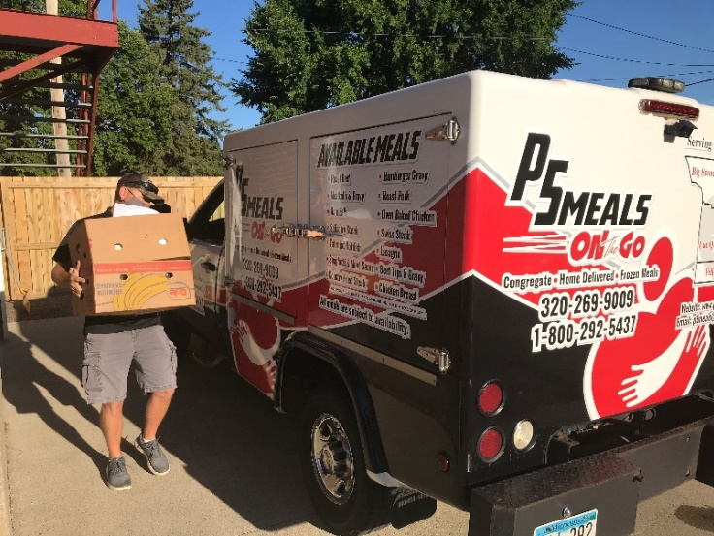
One of UWSWMN’s priority areas is hunger. Within that priority area the goal is to increase food access, nutritional awareness and outreach by:

- Connecting people to food support efforts/programs/opportunities.

- Increasing access to food and/or nutritious meals for people in need.

- Increasing nutritional awareness, food budgeting/stretching and/or basic cooking skills.

A few examples of local programming include: Prairie Five CAC Senior Meals (pictured), Marshall Food4Kids and Kitchen Table Food Shelf-Marshall and Tracy.

Learn More: https://www.unitedwayswmn.org/CI

Following is one example of the impact in this focus area:

A couple came to Tracy homeless having fallen on hard times. Once there a church gave them the parish house to stay in until they can get on their feet. They came to the food shelf as 1st timers. They were not aware they could even qualify for services and were reluctant to take as much as we could give them. They felt others must need it more although we knew they did not have a single item of food in their home. As volunteers helped one of them shop the other worked with staff to complete a SNAP application on site and it was then sent in. They left that day in tears as they stated they "didn't know generosity like this still existed and they are so grateful". A couple days later they called back stating they had already heard back and they’ll receive $137 a month in EBT benefits. We gave them the info flyer for transportation, as they both were transit drivers in Chicago before moving here. He was happy to hear UCAP offers help with getting the extra certification needed (to become a driver) and were going to look into applying for jobs. –Kitchen Table Food Shelf client

If you would like your donation to support the hunger focus area, please check the “hunger” box on your pledge form!

