OF SOUTHWEST MINNESOTA
UNITED WAY OF SOUTHWEST MINNESOTA
Sample Introduction/Kick-Off Email

Subject: LIVE UNITED TO THE POWER OF 5

Body:

[Company Name]’s United Way Campaign starts today!

Today we invite you to join co-workers as we commit to improving lives and strengthening our local communities by supporting United Way of Southwest Minnesota (UWSWMN).

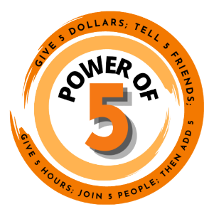
Join us in LIVING UNITED to the Power of 5!

There’s an African proverb that says “If you want to go quickly, go alone. If you want to go far, go together.” The value of community is that small efforts can go so much further by working together.

Supporting your community can be as easy as a $5 donation, giving 5 hours of your time or inviting 5 people to volunteer with you to maximize impact.

UWSWMN is committed to enhancing the health, education, financial stability, hunger and safety & well-being throughout the area they serve. With your donation of any size, they can start a ripple effect that creates change with a much more significant impact for every person in every community they serve, every day of the year.

Learn more about the impact being made by past donations to UWSWMN by viewing the campaign brochure (if you’re giving employees access to it) or going to UnitedWaySWMN.org.

Campaign Dates: _______ to _______

How to Give: [link to epledge if applicable] or list here how to get a pledge form from your company. If your company offers a match, mention it here. You can also include information about your campaign goals.

Company’s Campaign
Campaign Theme: add if applicable

Add dates for virtual events/fundraisers. Make sure to mention incentives!
- ________________
- ________________
- ________________

Much like the African proverb, we can go so much further when we work together so….

Let’s go together!

[CEO/Leadership Signature]

