United Way of Southwest Minnesota
KNOW THE FACTS

For your own knowledge and
to share with your co-workers!

#1: Donations to United Way of Southwest Minnesota
only support people living in Marshall and/or Lyon County.

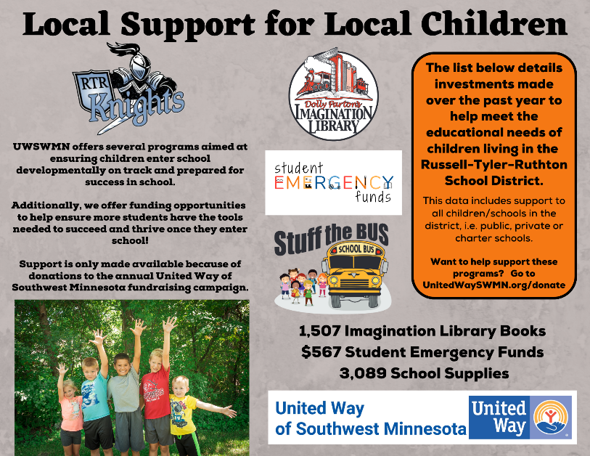
Incorrect.

FACT: United Way of Southwest Minnesota (hereafter UWSWMN) supports programs that help make a difference in the lives of people living in the following school districts: Canby; Clarkfield, Dawson/Boyd; Echo; Fulda; Hendricks; Ivanhoe; Lake Benton; Lakeview; Lynd; Marshall; Milroy; Minneota; Murray County Central; Russell-Tyler-Ruthton; Tracy Area; Westbrook-Walnut Grove; and Yellow Medicine East. Several of the internal initiatives that UWSWMN sponsors, including Stuff the Bus, Dolly Parton’s Imagination Library book program and Student Emergency Funds are available to enhance the lives of every child living in those school districts.

In fact, if you would like to see statistics similar to the ones in the left photo for a school district in our service area, go to UnitedWaySWMN.org/ambassador-resources and scroll down to “OUR INVESTMENT IN FAMILIES BY LOCAL SCHOOL DISTRICTS.” This chart is a snapshot of the investment and only includes the three key programs we sponsor.

Additionally funds are invested through our grant opportunities to programs which apply for funding and serve people throughout the UWSWMN service area. For full details of programs currently funded go to UnitedWaySWMN.org/CI.
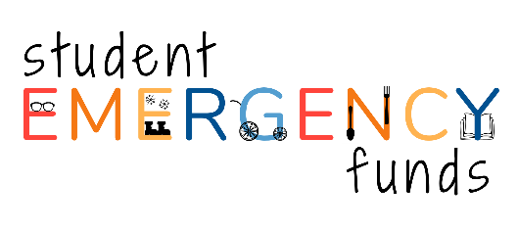
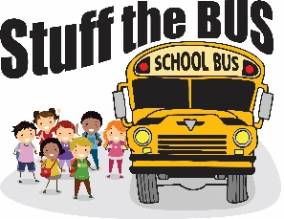

#2: A very small portion of my donation
to United Way of Southwest Minnesota stays local.

Incorrect.

FACT: United Way Worldwide (UWW) is the support organization for the nearly 1,100 local United Ways around the globe. UWW’s work is currently supported by a 1% membership fee paid by each individual United Ways such as United Way of Southwest Minnesota. The membership fee we pay to UWW is recouped by our local communities in training and services, as well as access to national corporate and employee giving campaigns.

#3: I only have a few dollars to give and
that can’t possibly make a difference.

Wrong.

FACT: Every dollar, just like every person, matters. When all the donations to UWSWMN are combined, they are a force for good in our community. UWSWMN depends on the generous support of everyone in the community. When each person or entity does what they can, we can continue to provide these critical services to those in need. Over 1,300 contributions were made by individuals, families, service organizations, clubs, schools, foundations and businesses to our most recently completed campaign. Gifts ranged in size from $1.00 to tens of thousands of dollars. When many entities give it adds up and makes a remarkable impact throughout our service area.

Individuals may not realize the impact of a gift $1 can have. UWSWMN can use a $1 donation to purchase any of the following for our Stuff the Bus back to school initiative: 1 box of colored pencils; 2 boxes of 24 count crayons; 50 eraser toppers; 7 two-pocket folders; 1 bottle of glue; 6 glue sticks; 1 box broad or fine tip markers; 3 notebooks; 20 pencils; 9 pens; 4 rulers; or 4 dry erase markers.
A donation of $5 can have even greater impact! Here are a few examples of what that $5 donation can accomplish when investment in some of our current community partner programs. It can: provide training materials for one Reading Corps tutor; provide a local pre-school child with a Fun in the Sun kit filled with summer activities; cover the field trip fee for young child whose family cannot afford it; provide two warm meals for a person living in a shelter; cover the cost of one personal safety alarm; provide a coloring kit for a child to use during a supervised visit; provide one bag of snacks to a child for one weekend; cover the cost of one older adult to receive gap financial support for two meals.
For more examples of the potential impact of various donation amounts, look for the “Donation Examples” that are part of the ambassador resources at UnitedWaySWMN.org/ambassador-resources.

LIVE UNITED TO THE POWER OF 5!

#4: United Way of Southwest Minnesota has extremely high overhead and hardly any of the funds raised actually go to the people and programs that need it.

Wrong.

FACT: United Way of Southwest Minnesota takes pride in the fact that over 82 cents (81.21%) of every dollar donated is invested in local people and programming. Data taken from our most recently completed audit showed our overhead ratio, computed using the net method, was 17.79%. Breaking that down even further, 11.06% was spent on local fundraising expenses and 6.73% was spent on local administrative expenses.

The Better Business Bureau’s Wise Giving Alliance recommends that a majority of a charity’s activities (defined as at least 65% of a charity’s total expenses in the past fiscal year) were directed to its program services. They go on to say that “fundraising is a necessary part of a charitable organization and here the phrase “it takes money to make money” very much applies. They believe a charity should spend no more than 35 cents to raise a dollar.

In 2013, GuideStar, BBB Wise Giving Alliance, and Charity Navigator wrote an open letter to the donors of America in a campaign to end the Overhead Myth—the false conception that financial ratios are the sole indicator of nonprofit performance.

They posted the following: “At the extremes the overhead ratio can offer insight: it can be a valid data point for rooting out fraud and poor financial management. In most cases, however, focusing on overhead without considering other critical dimensions of a charity’s financial and organizational performance does more damage than good.

Overhead costs include important investments charities make to improve their work: investments in training, planning, evaluation, and internal systems—as well as their efforts to raise money so they can operate their programs. These expenses allow a charity to sustain itself (the way a family has to pay the electric bill) or to improve itself (the way a family might invest in college tuition).

So when you are making your charitable giving decisions, please consider the whole picture. The people and communities served by charities don’t need low overhead, they need high performance.” Taken from https://nonprofitquarterly.org/the-overhead-myth/.

#5: United Way of Southwest Minnesota
doesn’t tell donors where funds are invested.

Incorrect.

UWSWMN is fully transparent when it comes to sharing what programs it invests campaign donations in. All programs funded by the annual UWSWMN campaign are listed on our website at UnitedWaySWMN.org/CI or UnitedWaySWMN.org/community-initiatives.

Community Impact Grants are the avenue through which most of the UWSWMN program investments are determined. In this process, programs that meet our funding criteria and are run by organizations that meet our parameters are able to apply for funding in the spring of each year. All grant applications are reviewed by a team of volunteers based on four criteria as follows: community need; impact; ability and evaluation; and financial management. These volunteers then make recommendations to our board of directors for approval.

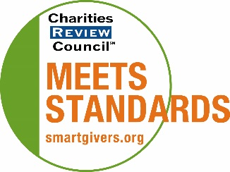
In 2021, UWSWMN was re-certified in accountability and awarded the Charities Review Council “Meets Standards” Seal. The Certification and Seal indicate that we meet all twenty-five of the Council’s Accountability Standards. The Accountability Wizard addresses a nonprofit organization’s performance in four critical areas: Public Disclosure, Governance, Financial Activity and Fundraising Practices. By participating in the Accountability Wizard, nonprofit organizations demonstrate responsibility, integrity and transparency to constituents.

We are also listed as a certified organization on the online Giving Guide of the Council’s Smart Givers Network, www.smartgivers.org and in the Council’s Smart Giver newsletter distributed to households, businesses and nonprofits. The Council’s Smart Givers Network is the one source of unbiased information where smart givers go for resources on informed giving. The general public can use this website to investigate an organization’s mission and programs and verify that the organization meets widely accepted standards.

If you would like, please take time to review UWSWMN’s most recent audit, annual report and Form 990 on our website at www.UnitedWaySWMN.org/PA. These documents detail program investments as well as our fundraising and administrative costs. If you prefer, email us at unitedway@unitedwayswmn.org to request a copy.
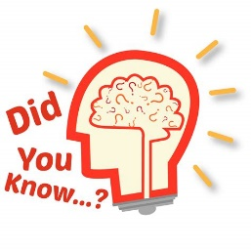
#6: I’ve seen this chart on the internet which shows
very little of my donation to United Way goes to those
who need support, AND their CEO is vastly overpaid.

Incorrect.
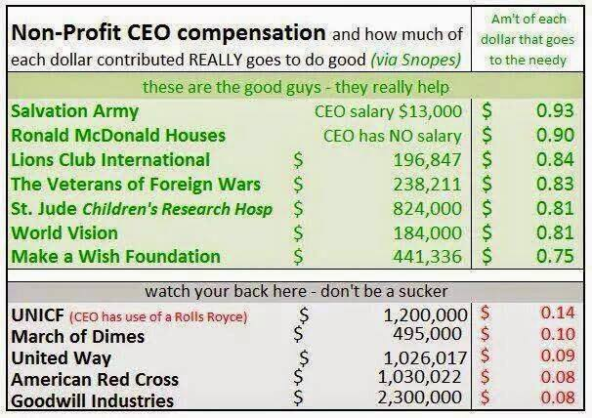
UWSWMN strongly encourage donors to exercise their right to contribute funds to organizations and causes that make a difference and an impact. The chart shown to the left (and others similar to it) that appear on social media are often inaccurate for all charities listed. Accurate information should always be pulled from a nonprofit’s 990, audit and annual report. Those documents typically include information such as what charities are spending funds on top staff, overhead costs, fundraising costs and investments in programs. Reputable charities, such as UWSWMN, make them available on their websites. This information is also a matter of public record.

UWSWMN is an independent nonprofit organization reporting to its own local board of directors. If you want to learn more about our financials, be certain you are looking at the financials for our specific United Way, not one of the other 1,100 United Ways that are independently operating. You can view our 990 and financials on our web-site at www.UnitedWaySWMN.org/PA. You will also find a list of our current board of directors and staff on our website. Our records are audited every year by an associate at Dana F. Cole & Company who has a local office located in Marshall, MN. Our organization was awarded the Charities Review Council Meet Standards seal which addresses a non-profits performance in: Public Disclosure; Governance; Financial Activity; and Fundraising Practices. You can view our profile at www.smartgivers.org.

UWSWMN takes pride in the fact that over 82 cents (82.21%) of every dollar donated is invested in local people and programming. Data taken from our most recently completed audit showed our overhead ratio, computed using the net method, was 17.79%. Breaking that down even further, 11.06% was spent on local fundraising expenses and 6.73% was spent on local administrative expenses.
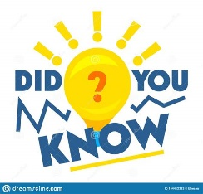
#7: United Way of Southwest Minnesota financially supports and/or endorses political candidates.

Incorrect.

FACT: UWSWMN does not engage in political campaign activity. IRS regulations have strict guidelines indicating that charitable nonprofits will lose their tax exempt status if they engage in certain political activities. Political campaign activity is defined as actions “supporting or opposing a candidate for public office” and is separate from lobbying for legislative activities, which charitable nonprofits ARE permitted to engage in with limitations.

UWSWMN does engage in advocacy work with local, state and national political representatives regardless of political party by talking about the issues facing southwest Minnesota constituents.

We are one of a handful of southwest Minnesota non-profits to have earned the Charities Review Council’s ‘Meet Standards Seal’ for performance in Public Disclosure, Governance, Financial Activity and Fundraising Practices. Read more at: www.SmartGivers.org.

#8: United Way of Southwest Minnesota only
supports programs for the poor.

Incorrect.

FACT: United Way fights for the health, education and financial stability of every person in every community. In southwest Minnesota, we focus on health, education, financial stability, hunger and safety & well-being. Almost 28,000 local people are being served in 2022-23 through UWSWMN initiatives, community partner programs and partnerships. Included in these programs is the Imagination Library book program which is available to every child, birth – age 5 who lives with their parent or guardian within our service area boundaries (there are no income requirements).

Some of the programs we support are focused on helping those who have limited financial resources to get a solid foundation for a healthy life. UWSWMN invests in a variety of programs aimed at helping improve lives and strengthen local communities. You never know when you or someone you love might need help, and everyone benefits from living and working in a healthy community.

For a full list of programs funded by the annual UWSWMN campaign, go to UnitedWaySWMN.org/CI or UnitedWaySWMN.org/community-initiatives.

