UNITED WAY OF SOUTHWEST MINNESOTA
Sample Education Impact Email

Subject: Education Impact Area

Body:

One of UWSWMN’s priority areas is education. Within that priority area the goal is to improve life-long learning and development by:
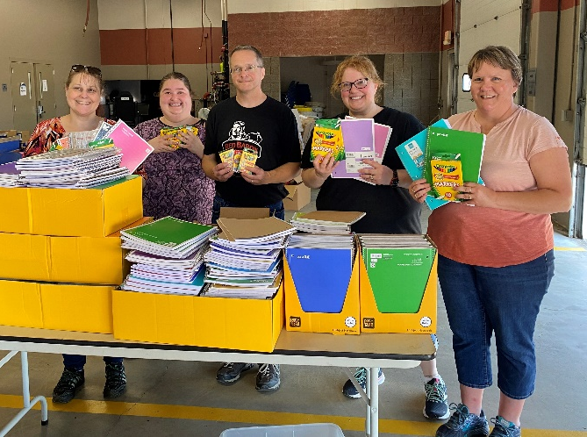
- Assuring children enter kindergarten developmentally on track in literacy skills, as well as in social, emotional and cognitive skills.

- Preparing elementary-age students to succeed in later grades and to graduate from high school.

- Assisting learners in exploring areas of interest and preparing for post-secondary education and/or career.

A few examples of local programming sponsored directly by United Way of Southwest Minnesota include: Imagination Library, Stuff the Bus (photo at right), Student Emergency Fund grants and Born Learning Trails.
Examples of other education related programs currently being funded by UWSWMN include: Practical Assessment Exploration System at Marshall Public Schools; Reading Corps volunteers at various local schools; and SWWC Student Enrichment Programs.

Learn More: https://www.unitedwayswmn.org/CI

Quotes from parents about these education investments:
REGARDING Imagination Library:
- I have two daughters who look forward to their monthly books from Imagination Library every month! It is a great program to encourage reading and keeping physical reading activities alive amid the technology rush. Our whole family is very grateful for this program - thank you.
- Thank you so much for the wonderful books! I am disabled, and I cannot take my children to the library on my own, so we are rarely able to go to the library to borrow books. But because of the Imagination Library program, we have books delivered to our mailbox each month! It is a wonderful treat for my children and me.
REGARDING 1,000 Books Before Kindergarten:
- This is such a fun program for kiddos and their parents! The ceremony is a special way to honor the kiddos and get them excited to continue reading.
- We are on our fourth child going through this program, and it is wonderful! It encourages and reminds us to keeping reading regularly to our kids.
REGARDING Reading Corps:
The current Murray County Central Elementary Internal Coach, who is a school leader, made the following remark about one of their tutors: “[She] is awesome! She is constantly looking for ways to improve and help her students achieve. She takes feedback well and implements it almost immediately in her tutoring sessions. She communicates with the classroom teachers and me about any schedule changes, absences, and student concerns. She is an important part of our K-1 literacy team, and we hope she can continue with us as long as possible!"
If you would like your donation to support the education focus area, please check the “education” box on your pledge form!

