UNITED WAY OF SOUTHWEST MINNESOTA
Sample Health Impact Area Email

Subject: Health Impact Area

Body:

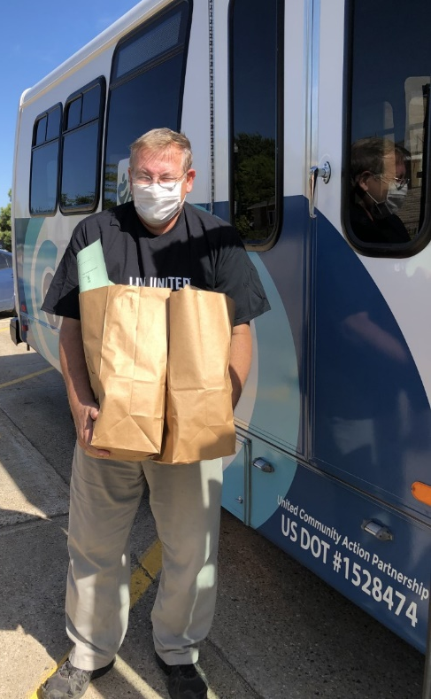
One of UWSWMN’s priority areas is health. Within that priority area the goal is to increase healthy behaviors and wellness amongst local people in the following ways:

- Achieving a healthier start to life.

- Increasing community conditions that support healthy behaviors.

- Promoting healthy eating and physical activity.

- Providing and increasing access to programs that improve physical, emotional and mental fitness.

The main program supported locally: Senior Meals & Meals on Wheels sponsored by Lutheran Social Services

Learn More: https://www.unitedwayswmn.org/CI

Following are notes of encouragement received by LSS from participants in the program:

- “I am wheelchair bound and I can’t cook for myself any longer. The meals help me to stay in my own home.”
- “I am so glad that my mom gets meals on wheels, I know she is getting a good nutritious meal and someone is checking in on her every day.”
- “The meals are a real blessing to me. I go to the pop-up events and pick up enough meals for a couple of weeks at a time. They are very good meals.”
- “I can’t afford many fruits and vegetables on my social security income. LSS Meals always has a great variety of different healthy food items that I enjoy.”

If you would like your donation to support the health focus area, please check the “health” box on your pledge form!

