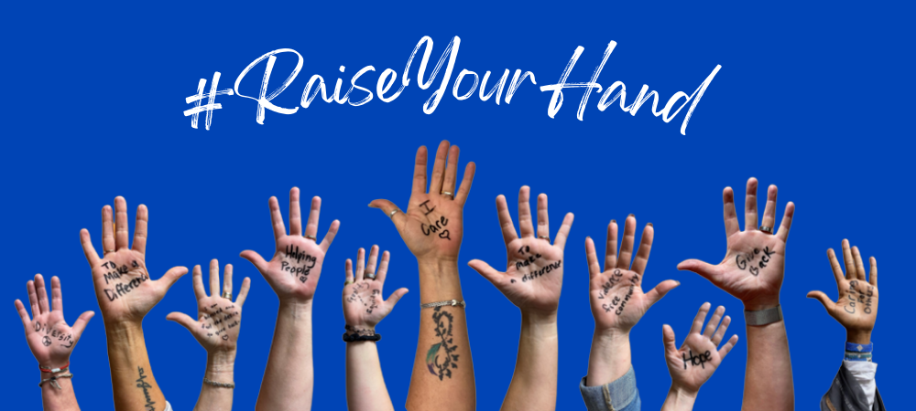
UNITED WAY OF SOUTHWEST MINNESOTA
Subject: How can a gift to United Way of Southwest Minnesota make a difference in local lives?

Body:

At the United Way of Southwest Minnesota, we believe that hope isn’t just a feeling – it’s a spark. A spark that ignites action, drives change, and creates brighter futures. Today, we invite you to Raise Your Hand with United Way of Southwest Minnesota and be part of our 2025-26 campaign.

Supporting your community can be as easy as a $5 donation, giving of your time or inviting people to volunteer with you to maximize impact.

When working together, a donation of any amount is worth far more than its face value.

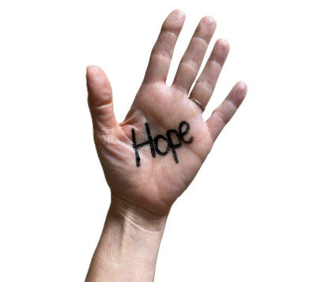
- Just $5 can cover round-trip transportation for someone experiencing homelessness to attend a job interview.
- A gift of $25 provides six days of hot or frozen meals to a senior in Yellow Medicine County.
- Donate $50, and a child will receive a free book every month for a year through Dolly Parton Imagination Library.
    - A generous $100 donation supplies one child with weekend snack bags for the entire school year!

Please consider making a financial contribution again this year because together, we can show the strength of a community that never gives up and create real hope where it’s needed most.

With your help, there's hope.

United Way of Southwest Minnesota is committed to advancing Youth Opportunity, building a Healthy Community, strengthening Financial Security, and fostering Community Resilience. Your support fuels meaningful change – creating pathways for success and well-being for every person in the communities we serve.

YOUR SIGNATURE LINE

