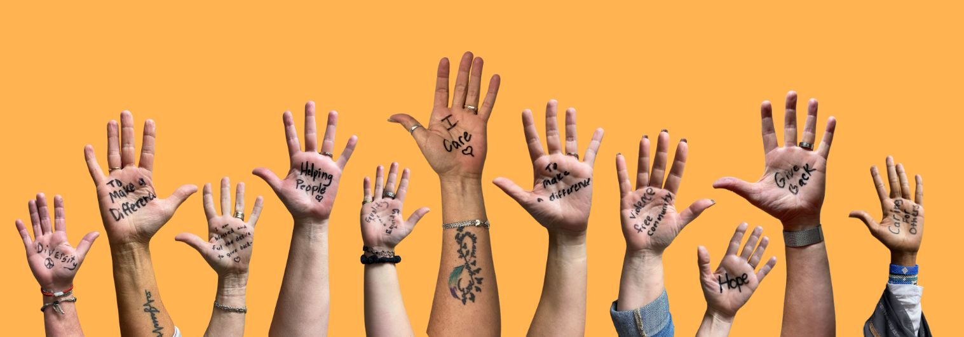
UNITED WAY OF SOUTHWEST MINNESOTA
Subject: How can a gift to United Way of Southwest Minnesota make a difference in local lives?

Body:

They say you can live 40 days without food, 7 days without water, a few minutes without breathing, but you can’t live one second without HOPE.” Today, we invite you to Raise Your Hand with United Way of Southwest Minnesota and create hope in our community.

Supporting your community can be as easy as a $5 donation, giving of your time or inviting people to volunteer with you to maximize impact.

Can a $5 donation really make a difference?

By working together, a donation of $5 is worth far more than its face value.

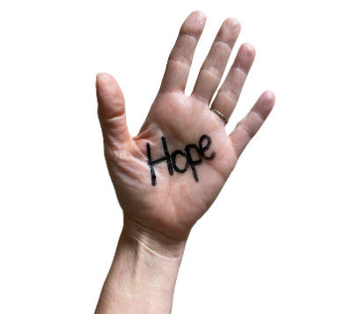
- One donation of $5 will purchase 500 pounds of fresh potatoes from Second Harvest Food Bank
- A $25 donation covers the cost of a whole week of meals for a frail senior recovering from illness or a hospital stay.
- Giving a $50 donation can supply shelter and food for a family for one night.
- With $100 donation two students would have personalized tutoring for one month.

We invite you to join us, to get involved, and to Raise Your Hand to create hope in our community.

Please consider making a financial contribution again this year because change doesn't happen alone.

With your help, there's hope.

United Way of Southwest Minnesota is committed to our community’s health, education, financial stability, hunger, and safety & well-being. With your support, we can utilize donations to create change with a much more significant impact for every person in every community we serve.

YOUR SIGNATURE LINE

