UNITED WAY OF SOUTHWEST MINNESOTA
Campaign Checklist

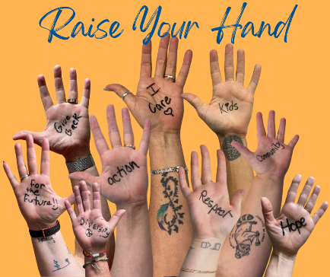
Before the Campaign
- Attend ambassador training or meet with a United Way of Southwest Minnesota (UWSWMN) representative.
- Secure CEO/Senior Management support.
- Recruit a campaign committee to help with the campaign.
- Review campaign history and set your goals.
- Determine your campaign plan, timeframe, and any incentives.
- Gather your campaign communications and any campaign materials. Visit UWSWMN website for a variety of resources! unitedwayswmn.org/ambassador-resources
- Schedule your kick-off, UWSWMN speaker and any special events.
- Promote the campaign with a campaign announcement.

During the Campaign
- Distribute pledge forms (or online giving information depending on your workplace) and campaign brochure to every employee.
- Promote the campaign, including your kick-off(s) and special events through numerous channels.
- Hold a mid-campaign committee meeting to review the progress towards the goal.
- Send regular progress reports to employees.
- Follow-up with individuals who have yet to turn in their pledge form.
- Send reminders about campaign events, incentives and deadlines.
- Share photos and progress with UWSWMN.

After the Campaign
- Collect all pledge forms and deliver them to UWSWMN, including a Workplace Campaign Report form with each submission of cash/checks/pledge forms. Make sure that you verify with your HR department or payroll personnel if they need the original payroll deduction pledge forms or if copies are acceptable. If it’s easier, call us to pick up your donation packet!
NOTE: You can either make a copy of the completed forms and bring those to the UWSWMN office (800 E Main St.), OR bring the original forms to our office and we will make copies for our records.
- Consider sending a thank you note to everyone including the campaign committee and the CEO.
- Publish a short story with photos and the results of your campaign via email, the company newsletter or company intranet.
- Hold a post campaign committee meeting to evaluate the challenges and successes of the campaign. Keep the notes handy for next year!
- Talk to the UWSWMN team so that we can continue to improve our service.

Year Round
- Keep employees updated on the year around activities of UWSWMN.
- Promote volunteer opportunities to employees. Check our website for volunteer opportunities throughout our service area!
- Use new hire packets to introduce new employees to the work of UWSWMN.
- Use retiree packets to keep outgoing employees engaged in the work of UWSWMN.
