Raise Your Hand
Email Templates

- Introduction Email:

Subject: Raise Your Hand for CITY/COMMUNITY in our United Way Campaign

Body:
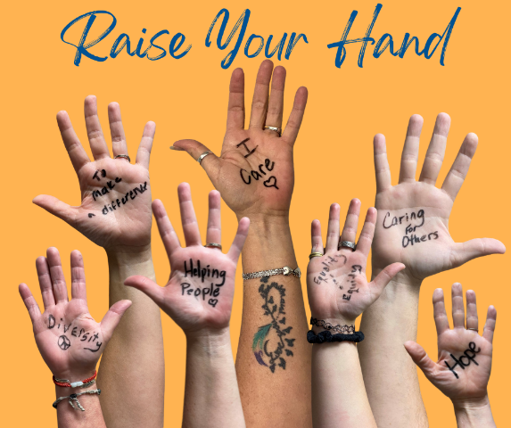

[Company Name]’s United Way Campaign starts today!

Today we invite you to Raise Your Hand with United Way of Southwest Minnesota for the health, education, financial stability, hunger, and safety & well-being of all COMMUNITY.

Help everyone here get the chance they deserve.

You might feel like it is impossible to tackle issues like poverty, hunger, or homelessness, but your gift can join others to solve those big challenges on a scale no single organization or individual can accomplish on their own.

This is your chance to live a life of purpose and compassion. This is your chance to lift others up here in CITY/COMMUNITY.

What does United Way do? www.unitedwayswmn.org

Campaign Dates: _______ to _______

How to Give: [link to epledge if applicable] or list here how to get a pledge form from your company. If your company offers a match, mention it here. You can also include information about your campaign goals.

Company’s Campaign
Campaign Theme: add if applicable

Add dates for campaign rallies, bake sales, potlucks, raffles, etc. Make sure to mention incentives, such as jean days, early outs, lunches, etc.

- ________________
- ________________
- ________________

You have the power to do good. United Way of Southwest Minnesota can amplify your impact.

Together, [Company Name] LIVES UNITED.

Thank you,

[CEO or WIC Signature]

